Task Title
Ansible-01
Objective
The objective of this task is to watch the Ansible-01 video posted on slack and worked on executing the initializing Ansible shown in video.
Prerequisites
List all requirements before starting:
- Master Controller server
- Nodes- workers
- Ad hoc commands

Issues Faced: Briefly mention issues and how you fixed them. Posted below in the last.
Conclusion
Conclusion has been provided for every task at the end.

Tasks
- Watch ansible-01 video and write down notes.

Ansible:
Ansible is an open-source tool for configuration management.
Ansible is used to provision infrastructure and used for deployments purposes as well.
Example: If we want to configure a package in 100 servers (ec2), we can use Ansible

To control all the 100 servers we need to install one Master server
Master server is called – Controller

In controller we need to have two components:
- Inventory/hosts
- Playbook

Inventory/hosts:
We need Inventory hosts to store all 100 servers IPs, so that we can communicate with all 100 servers from Controller.

Playbook:
Playbook is a place where we input what needs to be executed.
Task/play can be called anyways.
For example: Httpd/apache2
Task: httpd
Yum install state = latest
Task: start httpd
Service: httpd state = started
Ansible works on protocol: ssh and port= 22

Pre-patching and post-patching

We can write a playbook for pre-patching and post-patching, execute to bring up and down the servers.

Ad hoc commands

Scenarios:
- When patching activities are completed, then we need to check the runtime, when patching started/completed.
- We need to verify if all servers are responding, then we can use Ad hoc commands.
- We can use playbook as well to write execution script, but playbook should be simple, rest simple or small commands execution can be done via Ad hoc commands.
Example: ansible all -m “uptime”

Inventory/hosts:
In inventory, we store all Ips by dividing into groups.
- Development –Groups –Test (so, in test, I can change for 1 specific worker and add an IP)
- Staging
- Prod

Ssh- passwordless authentication
Ssh passwordless authentication needs to be performed on Controller all worker severs
Because, if we need to communicate with all servers and make changed to all via automation, then we need to do ssh-keygen in controller and paste the key in all worker servers.

Other configuration tools:
- Chef -pull based
- Puppet- pull based
- Salt stack- push based.

The above are the configuration tools similar to Ansible.
But Ansible is a better option to use, because:
- Ansible is a agentless (no mediator in between)
- Ansible works on push based.
- Ansible supports n number of plugins/modules.
- Ansible is developed in python language.

Ansible Architecture
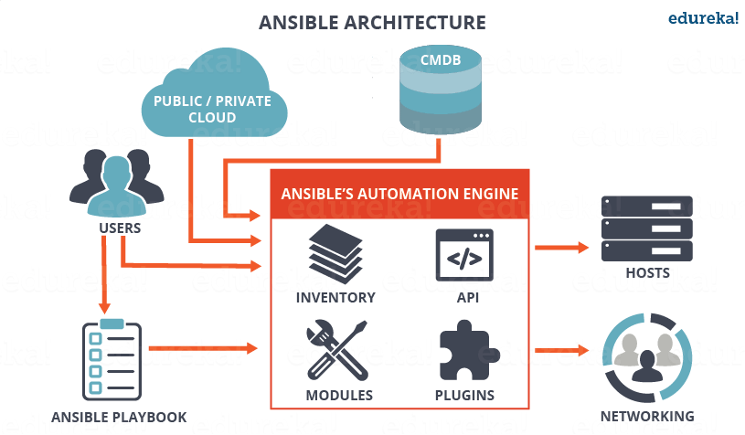
2. Setup one master and two worker nodes in ansible.

Step by step implementation:

- Navigate to ec2 and create 3 servers 1- Master controller and 2 worker nodes.

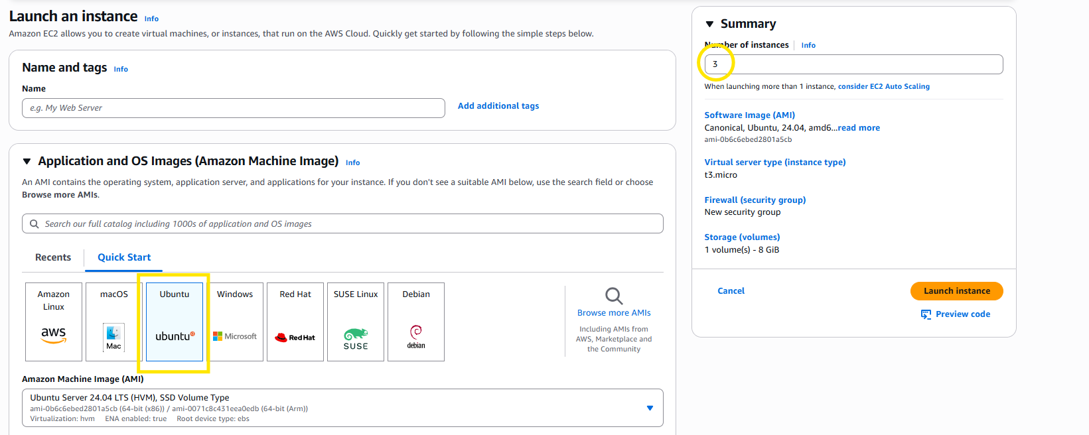
- Created new key pair
- Default VPC selected
- Default SGs selected
- Launch the instances.

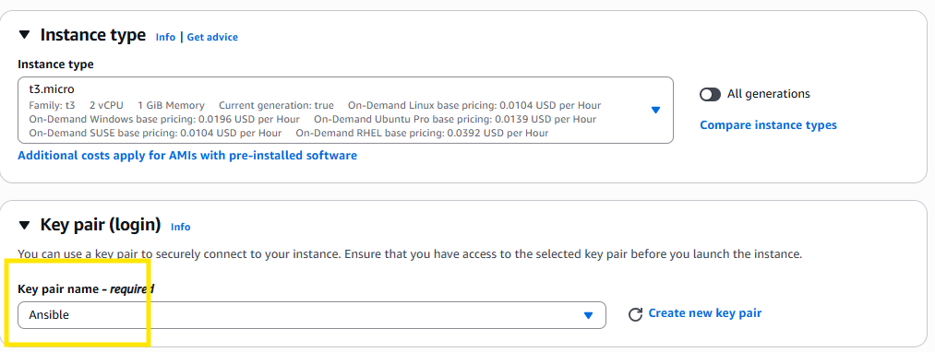
Let’s connect to Master-Controller
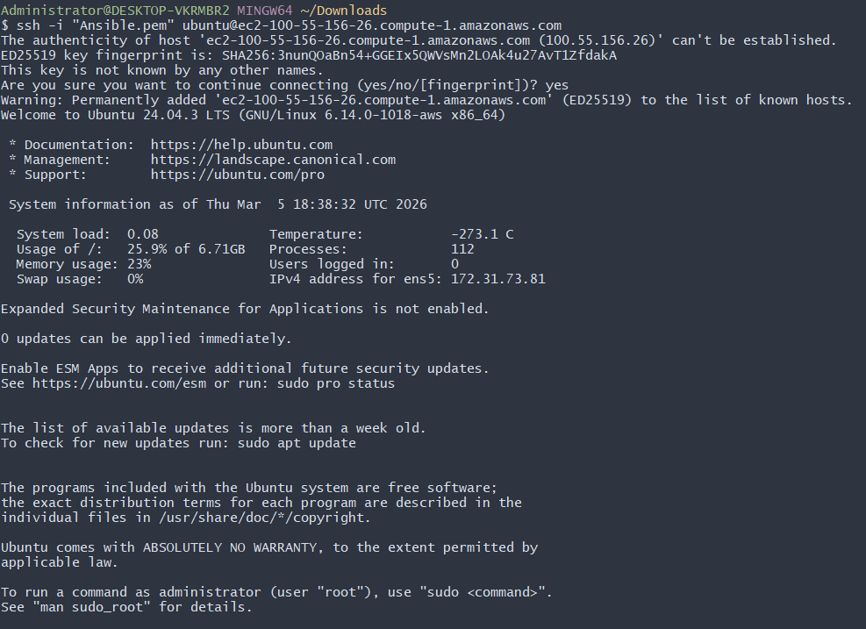
Verify python version
By default, python will be downloaded in aws.
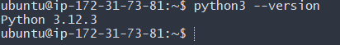
Now lets install our ansible in our machine
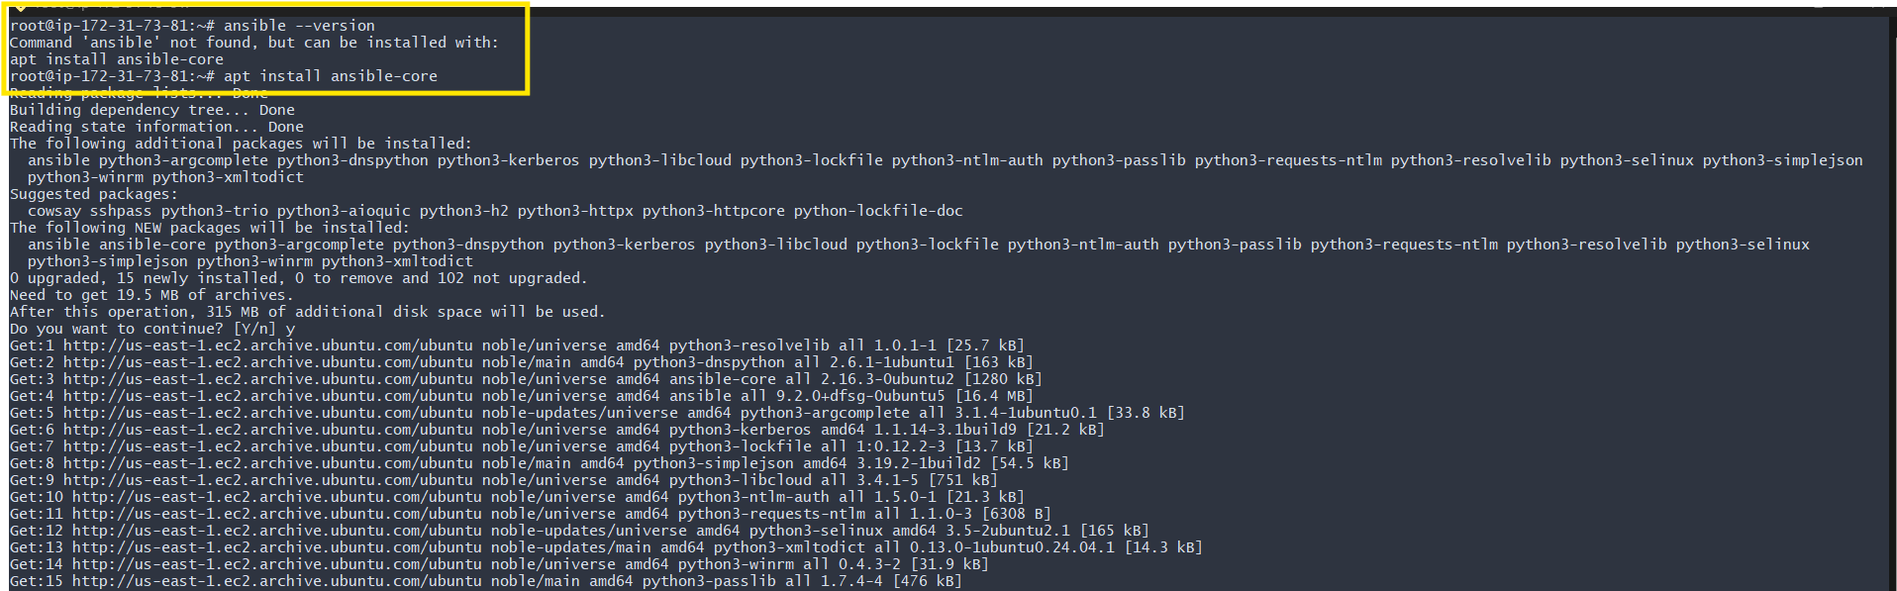
Ok now lets verfy it
Now can see we have successfully install ansible in our machine
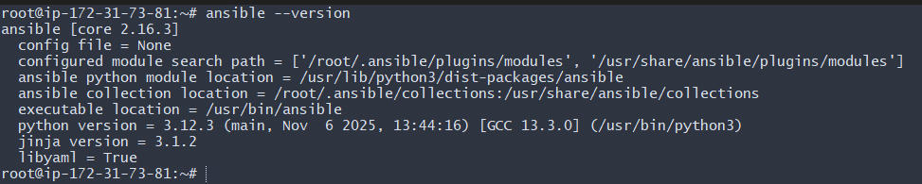
By default, Ubuntu does not create /etc/ansible/ansible.cfg or /etc/ansible/hosts
anymore — instead, you’re expected to create your own config and inventory in your
project directory.

- sudo mkdir -p /etc/ansible
- cd /etc/ansible
- vi /etc/ansible/ansible.cfg

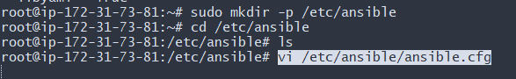
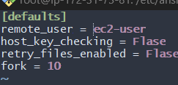

Created global inventory ( make sure its ur private ip not public) because private don’t change
sudo vi /etc/ansible/hosts
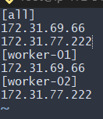

Save exit
Verify if hosts are available and communicating.
Success, host file is updated with Ips of Workers.
But, to communicate, we need to perform ssh-passwordless authentication.
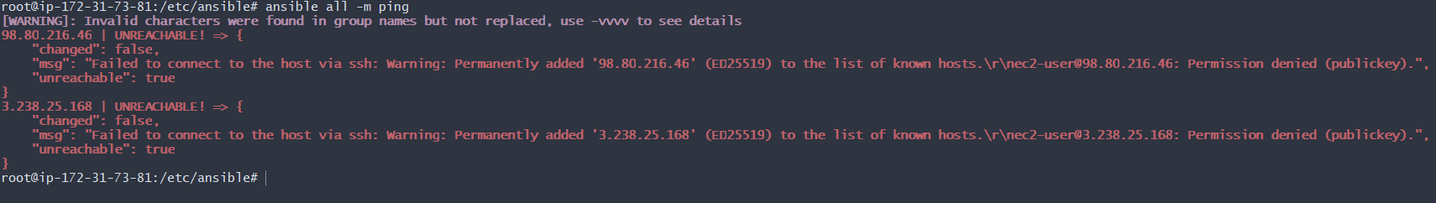
Next step- Set up passwordless authentication

Generate a ssh-keygen in Controller
Ssh-keygen
Cat /root/.ssh/id_ed25519.pub
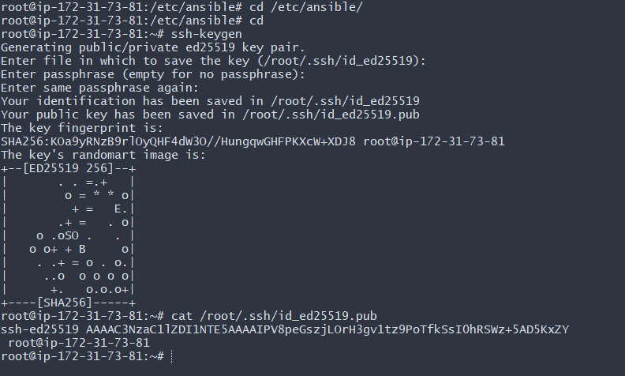
Its time to copy the above key and paste in both the worker servers.
1st worker- Worker-01
Now same steps with working-02
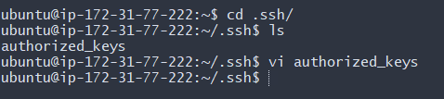
Now, we have provided the path to communicate with our workers.
Let’s verify if we are able to communicate from controller.
Success- we can now communicate automatically with our workers.
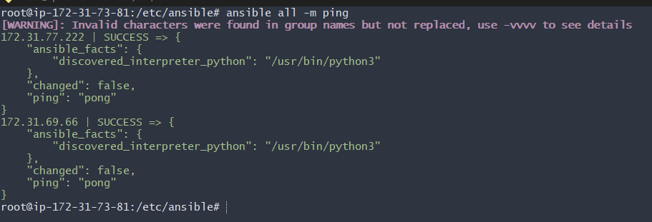

3. Execute the ad hoc command shared in #dvps-cloud-documents-12 Channel.
Step by step Implementation:

In this task, we shall execute few ad hoc commands-
- To check the connectivity between slaves
ansible all -m ping

Ansible Worker-01 -m ping
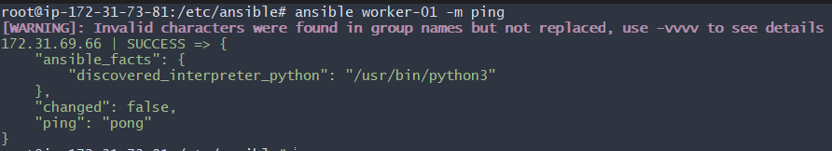
Ansible Worker-02 -m ping
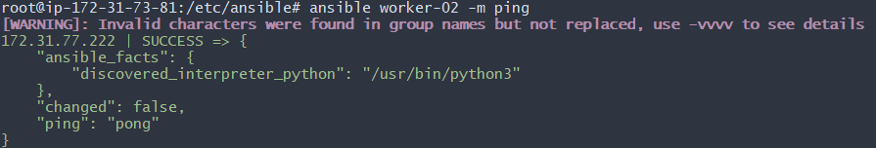
By using the above workers 01 and 02, we were able to fetch from hosts file

How to gather facts of slave machine
# ansible all -m setup
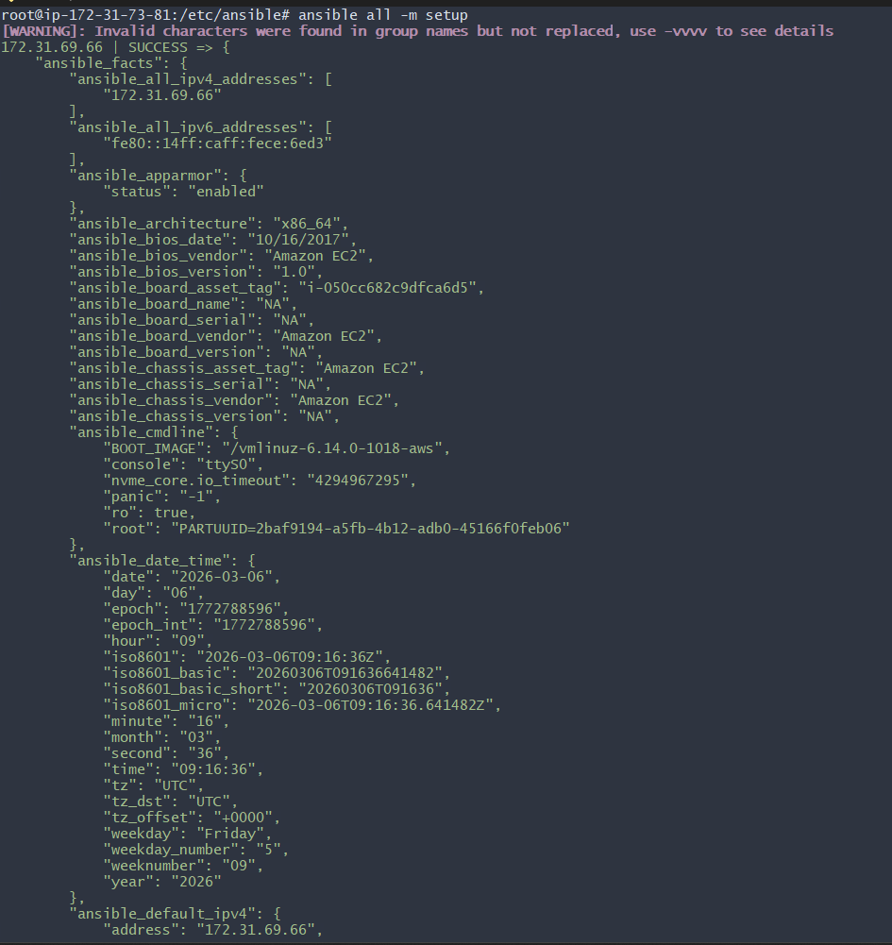
TO check the uptime of a slave machine
# ansible all -a uptime
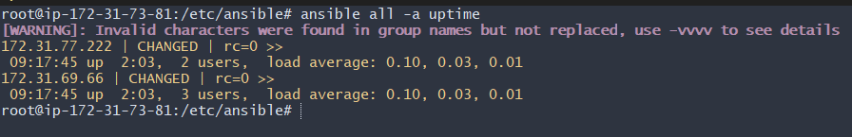
Ansible all -m ping -vvvv
—-> to check with all log details
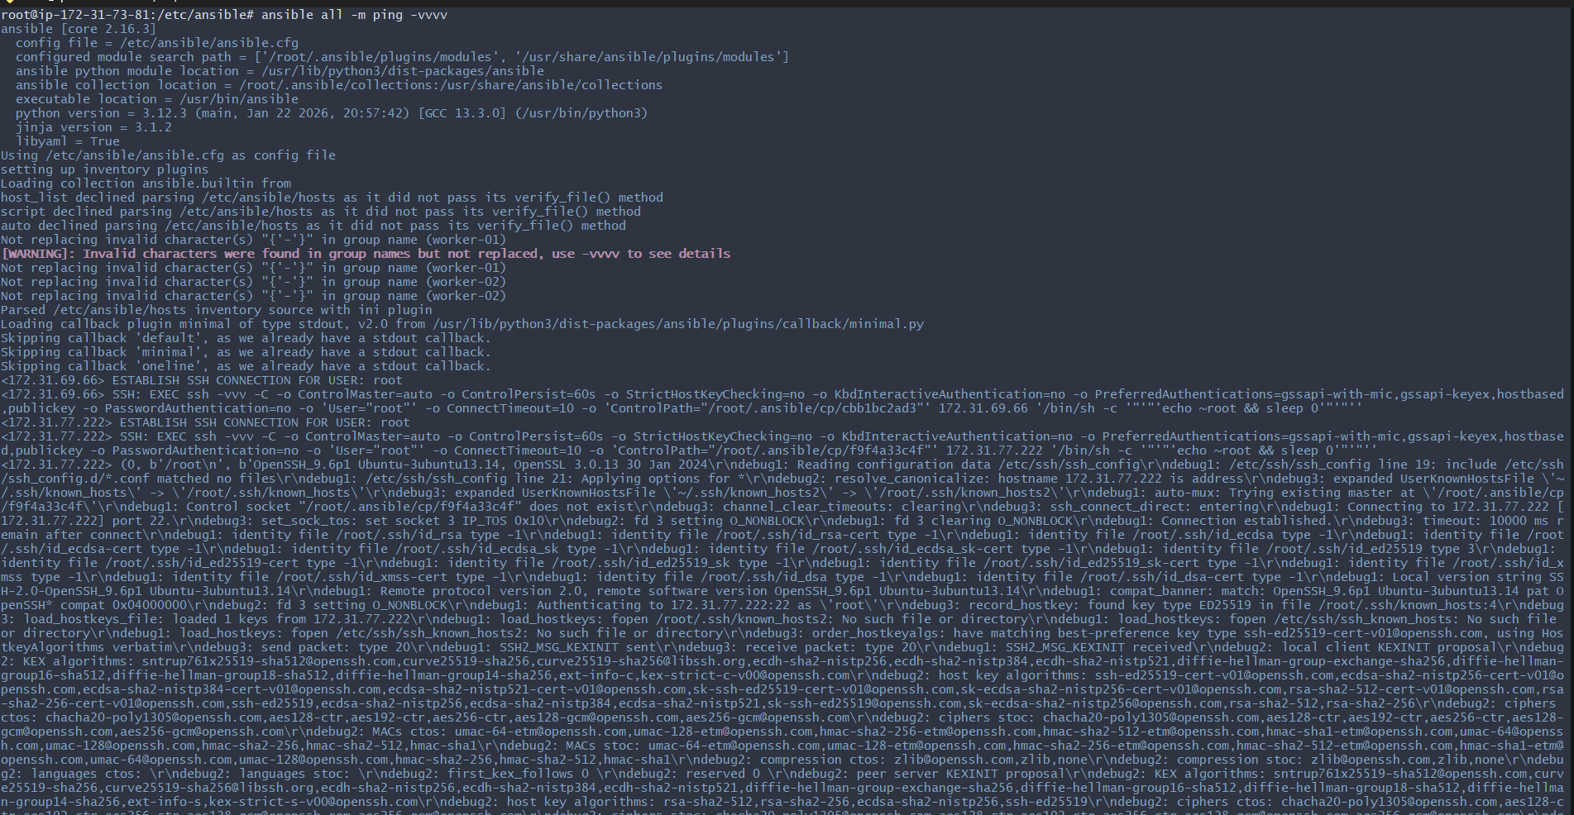
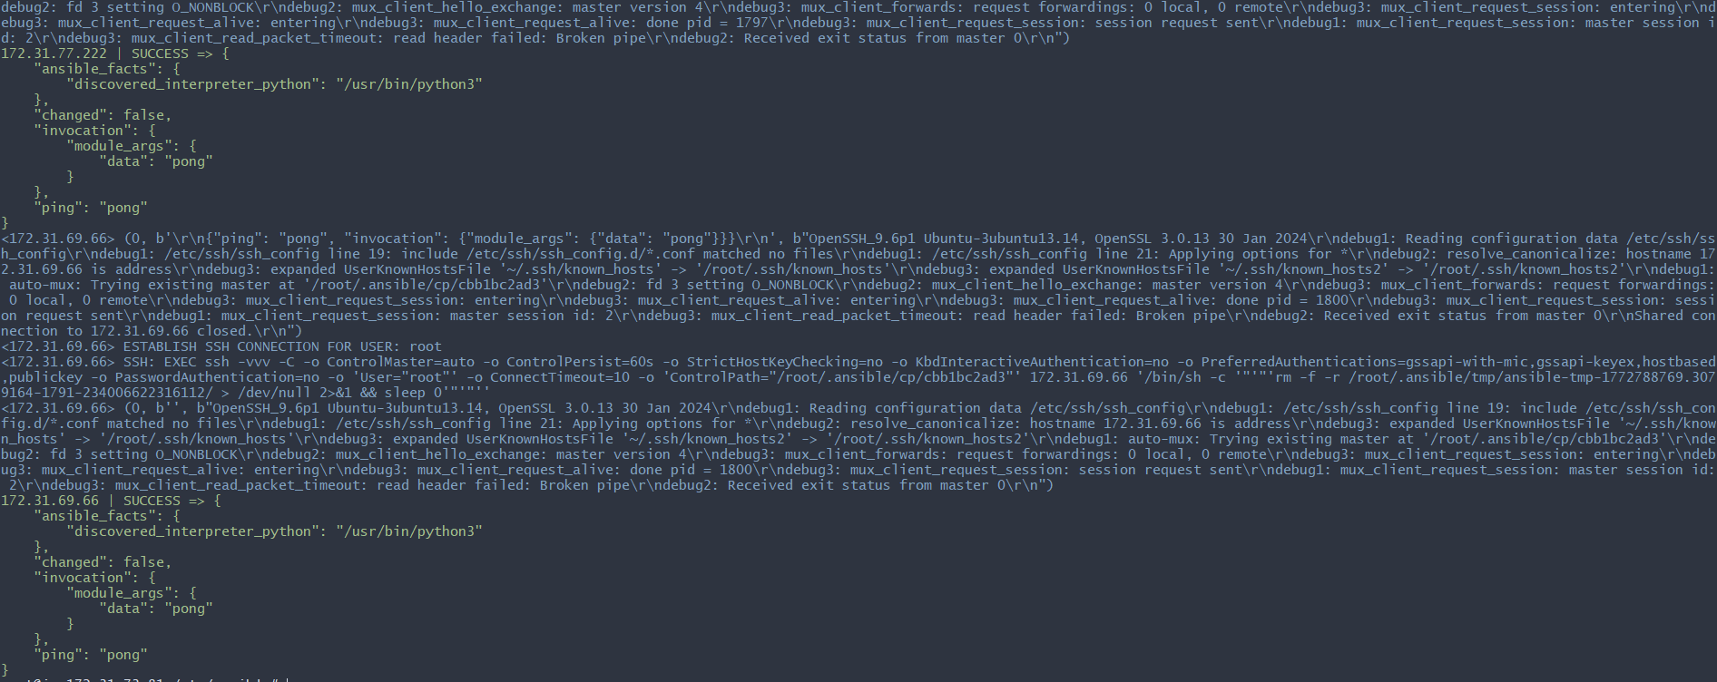
#check the free memory or memory usage of host
ansible all -a "free -m"
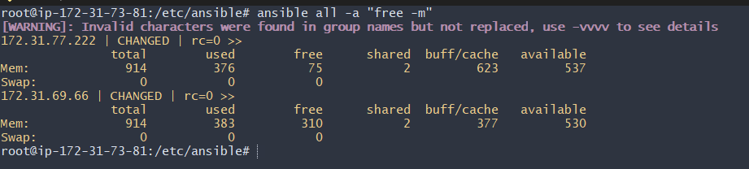
Create directory using shell module
ansible all -m shell -a “mkdir ansible.log”
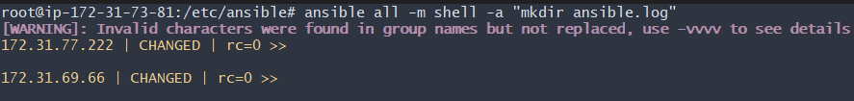
what it does it will create ansible.log directory in all severs.
We verified in worker-01 machine.
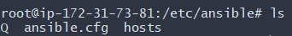
Before installing the package, we need to update the packages using command- ansible all -m shell -a “apt update -y” –become
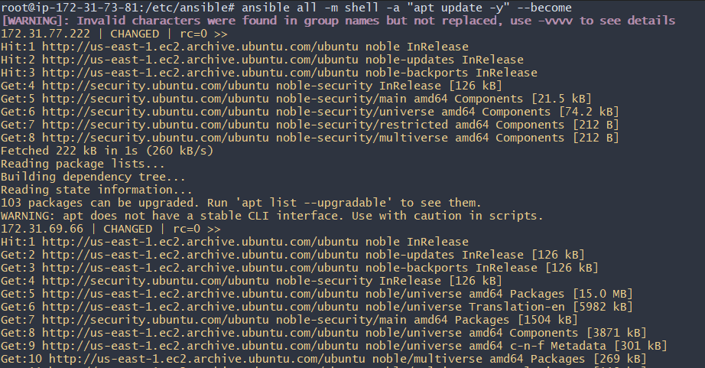
Install a package using yum command
ansible all -m yum -a "name=httpd state=installed"
—> We are using ubuntu
ansible all -m apt -a “name=apache2 state=latest” –become
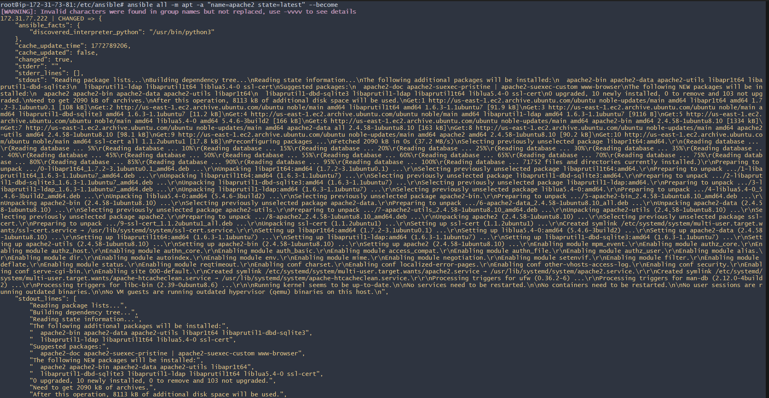
now check your other workers servers if apache2 package
is installed or not
working on server-1
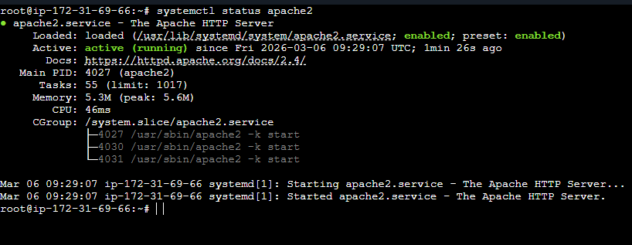
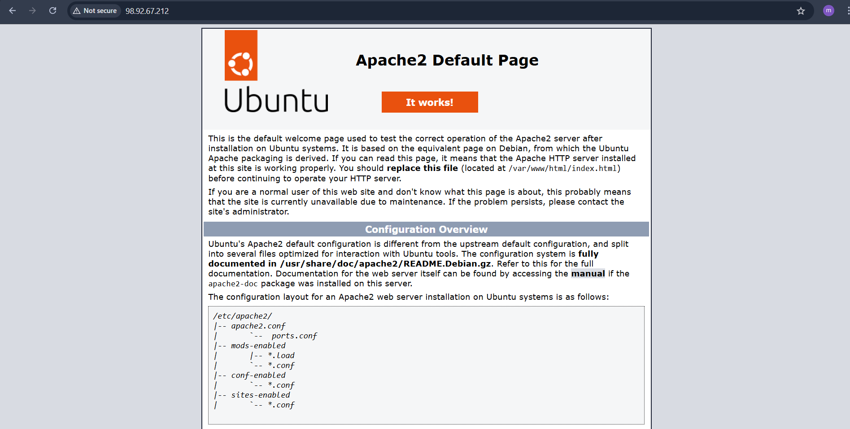
# Start or stop the service
# To Start
ansible all -m service -a "name=httpd state=started” --become
enabled=yes"
# To Stop
ansible all -m service -a "name=apache2 state=stop enabled=yes"
To stop
—-> ansible all -m service -a "name=apache2 state=stopped
enabled=yes" –become
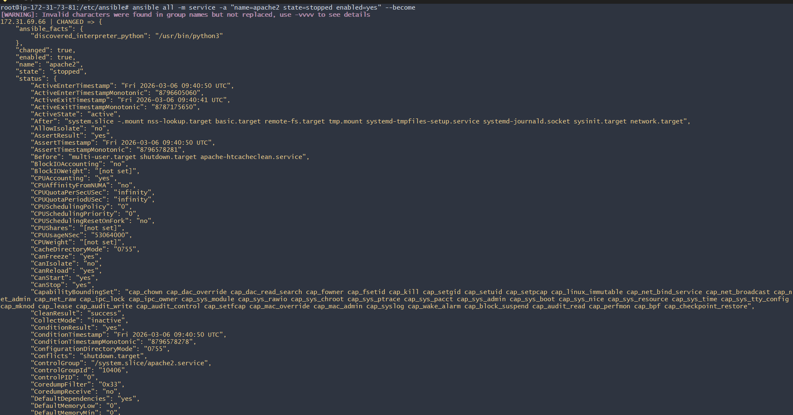
Let’s verify in worker machines
Success.
